ARTICLES
Channel: (The Play…, The Scene, News & Events, How It Works or Awards Central)
Title:
Dek*:
Contributor:
Tags:
Body:
Image:
Related articles (optional, up to 2):
Program Spotlight (optional):
*Dek is the short copy/description below the headline on the article page and on the channel page. This does not display on the homepage.
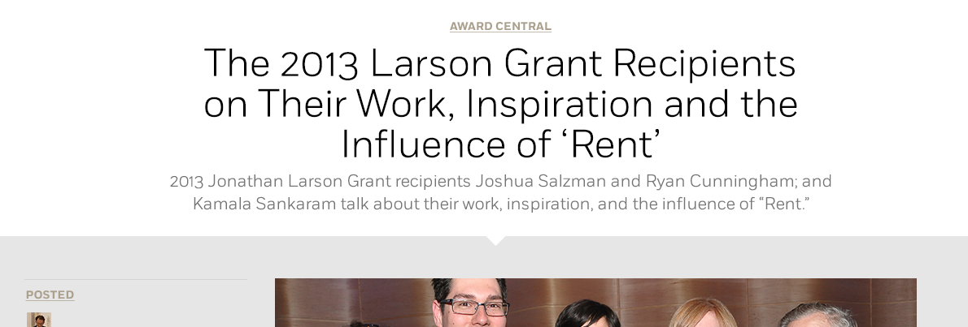

EXAMPLE
Channel: News & Events
Title: Stars Shine at The Wing’s Annual Gala
Dek (optional but recommended): Nearly $700,000 raised for education and outreach programs in honor of Hal Prince!
Contributor: Joanna Sheehan Bell
Tags: Wing Gala, Hal Prince, Angela Lansbury, Sierra Boggess
Body:
All proceeds from the evening will benefit the Wing's education and outreach programs, which include SpringboardNYC, the Theatre Intern Group, the National Theatre Company Grants and the Jonathan Larson Grants, and will also support free access for students, aspiring professionals, and the general public to programming on our website.
The evening's program featured performances from Harold Prince-affiliated shows, including Glenn Close, Santino Fontana, Sierra Boggess, Emily Skinner, Richard Kind, Jim Wann, and LaChanze. Angela Lansbury presented Mr. Prince with his honor. Watch a slideshow from the event: (embed: http://youtu.be/-xMj-wbh8Fo)
Image: Galaphoto.jpg
Related articles (optional, up to 2): Save the Date: 2014 Wing Gala Announced; Classic advice: A conversation with Hal Prince
Program Spotlight (optional): Donate

Example Headlines/Deks

Title: Congratulations to the 2014 National Theatre Company Grant Winners!
Dek: The Wing awards ten phenomenal theatre companies from Portland, OR to NYC

Title: Spring into your Theatre Career! Apply Now for SpringboardNYC
Dek: Turn your talent into a successful career with SpringboardNYC

Title: 2013 Jonathan Larson Grant Recipients Talk About Their Inspiration and the Influence of “Rent.”
Dek: Meet the talented Joshua Salzman, Ryan Cunningham and Kamala Sankaram, this year’s Larson Grant winners.

Title: Young & Hungry: Sarah Robertson
Dek: Actor, Singer and Life Enthusiast

Title: Edward Albee: Suspending Disbelief
Dek: American playwright Edward Albee weighs in on the play that changed his life.

VIDEO
Channel (The People, The Process or The Word)
Title:
Tags:
Video Embed Code:
Body/Description:
Related Videos (optional, up to 4):

EXAMPLE
Channel: The Process
Title: Before the Show: Prep with Billy Porter of Kinky Boots and Patina Miller of Pippin
Tags: Behind the Scenes, Kinky Boots, Pippin, Billy Porter, Patina Miller, Actors
Video Embed code: *vimeo/youtube embed*
Body/Description:
Ever wonder what happens before the show? Working In The Theatre gets full access with Billy Porter (Kinky Boots) and Patina Miller (Pippin) as they prepare for the stage.
It's a rare behind the scenes glimpse that you'll only see on Working In The Theatre as the Wing goes into the dressing rooms and minds of two Broadway stars just hours before curtain
Related videos (optional, up to 4):
Cues from the 2011 Tony Nominees, Setting the Stage: Kinky Boots, Working in the Theatre: Design

